INSTRUCTIONBEGIN
3.3.3. Power DOL Assessment
Testing time limit: 30 mins.
INSTRUCTIONEND

- What is a basic principle of the Declaration of Independence?
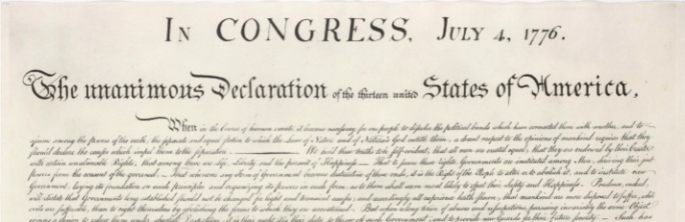
- Rulers receive their power directly from God.
- People cannot be trusted to govern themselves.
- People do not have the right to rebel against a government.
- Government receives its power from the consent of the people.
QTYPE: MC
ANS: D

- The factor that had the greatest impact on the economic
development of the colonies was:
- the relationship of the settlers with the native peoples.
- the support of the monarch.
- the geographic location of the settlement.
- the work ethic of the first settlers.
QTYPE: MC
ANS: C

- The first example of colonial Americans trying to ensure
democratic practices in governance was __________.

QTYPE: SA
ANS: The Mayflower Compact

PASSAGEBEGIN
PASSAGEHTMLBEGIN
Read the selection and choose the best answer to each question.
The Changing Sea
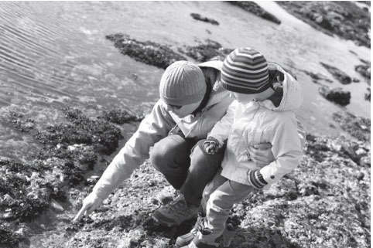
Ethan is eight years old. One day, he went to the beach with his family. He and his sisters built a giant sandcastle. After lunch, Ethan and his mom went to look for shells. When they came back, they saw that the sandcastle had disappeared. Ethan wanted to know what happened. His dad and his sisters told him the castle had been covered with water by the tide.
What Are Ocean Tides?
Every day, along coasts around the world, the level of the ocean water changes. In the morning, the level of the water might be low. Six hours later, the level of the water is usually higher. This regular rise and fall of the ocean is caused by tides. When the water level rises it is called high tide. When the water level falls it is called low tide.
What Causes Ocean Tides?
Ocean tides are mostly caused by the pull of gravity between the moon and Earth. Gravity is a force that causes objects to move toward each other. The moon’s gravitational pull is strong enough to draw the water in Earth’s oceans toward the moon. This causes large amounts of water to move across the oceans. High tides are a result of this movement. If the tide is high in one part of the world, it is low somewhere else.
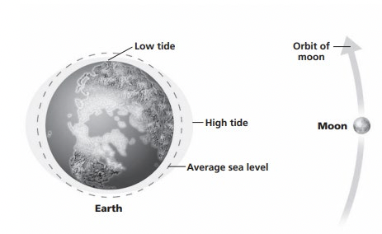
How Can People Use the Tides?
For hundreds of years, people have been able to rely on low and high tide. Ocean tides are dependable. In fact, people can even look up the times for low tide and high tide each day. Understanding the pattern of ocean tides can help keep people safe. Rising tides can be dangerous. Knowing about the tides can also help people do their jobs. For example, people who dig for clams wait until low tide. Then it is easier to find the shells in the sand. Some people prefer to go fishing during high tide. Scientists wait until low tide to study sea creatures and animals in tide pools. A tide pool is an area along a coast where little water is left after the tide goes out.
PASSAGEHTMLEND
- In paragraph 1, what does the word disappeared mean?
- was placed underwater
- was broken apart
- could not be seen
- did not look the same
QTYPE: MC
ANS: B
- According to the selection, what is one thing people wait for high tide to do?
- Study tide pools
- Collect shells
- Make energy
- Catch fish
QTYPE: MC
ANS: A
PASSAGEEND

PASSAGEBEGIN
PASSAGEHTMLBEGIN
Read the selection and choose the best answer to each question.
The Plains
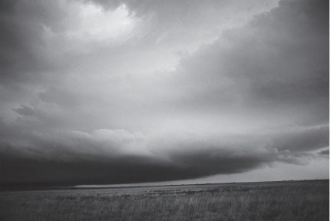
The year is 1853, and I am only eight,
Same old chores, but a helper on the trail;
Traveling across the lonely land.
Moving to a brand-new state.
  - Pa, Ma, my three young sisters and I
With our covered wagon packed full.
Each night, an endless journey’s rest.
Light the fire, warm the cornbread, eat.

From edge to edge, nothing there
10 On the great large plain.
Just big blue sky and rolling grass
And maybe some clouds of rain.
PASSAGEHTMLEND

- Lines 1 and 2 best support the idea that the speaker:
- discovers new things along the trail.
- misses her friends and old home.
- wishes that she was older than eight.
- feels proud that she can help her parents.
QTYPE: MC
ANS: A
- What is the meaning of chores in line 2?

QTYPE: SA
ANS: work typically done as part of living at home

- The description in lines 9 through 12 helps the reader picture:
- how the plains look.
- which animals are on the plain.
- where the wagon stops.
- how life was in 1853.
QTYPE: MC
ANS: A

PASSAGEEND

- What was the name of the ship the Pilgrims used to travel to Plymouth?
- Nina
- Santa Maria
- The Mayflower
- Jolly Roger
- 66 days
- 4 months
- 42 days
- 7 weeks
QTYPE: MC
ANS: D
- From memory, complete this sentence from the Declaration of Independence:
“We hold these truths to be self-evident, that…”

QTYPE: RU
ANS: 10

